Advanced Mechanical Design, University of Rochester
Final Design Report
Spring 2023
 | TEAM DRILLCART CHARLIE
Braydon Bush | Noah Braid Ryan Eamer | Caiden Larsen | Nicole Mercer

ABSTRACT
Getting around campus effectively is a daily struggle at the University of Rochester. This project aims to create a drill powered vehicle to navigate campus which is an affordable, efficient, and convenient solution. The best vehicle will be determined by an endurance race with a Monte Carlo start to determine a winner among the other competing teams. The cart is divided into five different subsystems: drivetrain, brakes, frame, steering, and usability. Each of the five team members were responsible for a specific subsystem.

PROBLEM DEFINITION
At the University of Rochester, the only method of reliable transportation provided by the university is the school shuttles. The school shuttles run every 15 minutes but only stop at one location on campus, causing a long walk for some to classes. These long walks create longer commute times for students, which is not appealing to most. With only two main roads on campus, adding more bus stops would greatly increase the traffic around campus. With these faults, there is a great opportunity to create an alternative mode of transportation. Developing drill powered carts would provide a more convenient method of transportation on campus, specifically allowing access to spots the buses cannot get to efficiently. Given the hectic schedule of college students drill powered carts would provide a more convenient and faster way to get to class in an environment where every minute is crucial.

REQUIREMENTS, SPECIFICATIONS, DELIVERABLES
Deliverables:
- Working cart on design day (April 28th, 2023)
- Technical report including test data
- Theory of operation manual
- Project presentation
Requirements:
- Vehicles will be powered by a single electric drill (each team will use the same drill)
- Vehicle body must be made from plywood
- Vehicle can be optimized by each individual team
- Vehicle must have a lap style safety belt and horn for safety.
- Pinch points must be guarded and pass inspection by Professor Muir
- Payloads will be standardized
- Cart must sustain the weight of the driver
- Cart cannot use a standard steering wheel
- Cart must be able to maneuver the course
- Each team must use the same wheels
Specifications:
- Vehicle cannot exceed 25 mph
- Payloads must be within 5 lbf of each other
- Maximum brake distance of 15 feet at maximum speed
- Vehicle must have more than or less than 4 wheels
- Turning radius of less than 11 ft
- Vehicle must fit inside a 6x4x4 ft volume
- Cart must be able to climb at an incline of 4.28 degrees

CONCEPTS
Frame:
Categories | Rectangle | Custom  Light Weight | Custom  Braced | Custom  Light Weight and Braced
Cost | 0 | 0 | -1 | -1
Ease of Assembly | 0 | -1 | -1 | -1
Weight | 0 | 2 | -1 | 1
Stability | 0 | -1 | 2 | 2
Ease of Integration | 0 | 2 | 2 | 2
Manufacturability | 0 | -1 | -1 | -1
Total | 0 | 1 | 0 | 2
Table 1: Frame Subsystem Selection (Pugh) Matrix

Multiple design concepts were discussed and analyzed for the frame subsystem. Areas of consideration were as follows: Cost, weight, ease of assembly, stability, ease of integration, and manufacturability. To adhere to the requirements of the project, the vehicle body must be made from plywood. The plywood body proved difficult to yield under the given use case, and it was therefore determined that maximum deflection was a more critical factor in determining the overall design and was considered during the analysis and testing phases. Each design was analyzed with a simple static analysis, to estimate the maximum deflection due only to the weight of the driver. The baseline chosen for the frame subsystem was a simple rectangular shape, with no additional bracing. The remaining concepts that were traded were as follows: A custom shaped, light weighted design, a custom shaped design with additional bracing, and a custom shaped, lightweight design, with additional bracing.
After initial analysis using Siemens NX, it was determined that a custom shaped, lightweight design, with additional bracing underneath the cart was the best option. This design provided the rigidity needed to support the driver, while saving weight by removing material from the frame in low stress areas. The custom shape of the frame gave the front wheels clearance to properly execute the required turning radius.
The frame concepts were tested with a driver load of 210 lbf, located at an arbitrary position, as the exact position was unknown during the concept selection phase. Under the above-mentioned load conditions, the custom shaped, lightweight design, with additional bracing underneath yielded a mass of 29.3 lbm and maximum deflection of 0.094 in. Additional results from the initial analysis can be found in Annex B.
During the manufacturing and testing phase of the frame construction, it became apparent that additional support would be needed to accommodate bending seen between the two front wheels. To account for this deflection, a wooden support that spanned the distance between the front spindles was mounted on top of the cart. The addition of this support member provided the rigidity needed to minimize the bending seen when the driver load was applied. Additionally, the cross section and material of the bracing was changed during the testing phase of the frame. For further explanation please see the materials selection section of this report. An updated static analysis of the finalized frame assembly under driver loads can be found in Annex B.

Steering:
Categories | Front Axle Rotation | Lever Weld to Front Axle | Lever Weld to Front Axle and Join between Levers | Ackerman Steering
Cost | 0 | 1 | 1 | 1
Ease of Assembly | 0 | -1 | -1 | -1
Mobility | 0 | -1 | 1 | 2
Weight | 0 | 1 | -2 | 1
Manufacturability | 0 | 1 | -1 | 1
Total | 0 | 1 | -2 | 4
Table 2: Steering System Selection (Pugh) Matrix

When considering the steering mechanics for the cart a lot of deliberation went into each design. With the given requirements and specifications, the cart could not have four wheels and a traditional steering column system. Each concept was broken down into components to determine the best model; which are cost, ease of assembly, mobility, weight, and manufacturability. It was determined that 3 wheels, 1 in the back and 2 in the front would provide the most efficient design of the cart. Due to this, our baseline for the steering Pugh matrix seen in table 2 is front axle rotation. Using NX models, an Ackermann steering connection would be necessary for the steering. Ackerman steering was crucial because it improves maneuverability of the cart, reduces tire wear, improves stability, and prevents the steering from locking out [2]. This optimizes the carts turning radius which is needed to pass the specifications. Ackerman steering prevents the inside wheel from plowing into a corner when making tight turns allowing for a tighter turning radius.
Once the Ackerman steering was decided upon the next hurdle was to determine the steering control of the cart. A few ideas were proposed ranging from using feet to steer to a fixed connection along the whole steering assembly. The optimal way to steer the cart was determined to be spindle connected with an Ackermann connection and controlled by hand levers by the driver’s side. (Annex B). The integration of the Ackerman steering and levers as seen in Annex B provided a reliable and stable system. The connection between the levers and Ackerman steering is a custom steel welded spindle. The spindles allow both systems to operate with each other effectively. With additional material analysis the steering levers which were originally going to be made of steel were switched to PVC. PVC is durable and lightweight which helped keep the overall weight of our cart low in addition to allowing similar steering mobility. With additional NX modeling and some trial and error the ideal steering model for this design was Ackerman steering with PVC levers which the driver controls.

Drive Train:
Categories | Single Gear | Bike Gear | Torque Converter
Cost | 0 | 0 | -1
Ease of Assembly | 0 | -1 | -1
Stall Limit | 0 | 0 | 1
Max Speed Control | 0 | 1 | 1
Innovation | 0 | 0 | 1
Total | 0 | 0 | 1
Table 3: Drive Train Selection (Pugh) Matrix

Table 3 is the Pugh Matrix that was developed to determine which of the drive train options should be selected. The categories of cost, and ease of assembly are straightforward. The bike gearing and torque converter would be more difficult to assemble due to the extra components and alignment necessary. The stall limit criterion is a product of the stall torque of the drill. The rating of stall limit was the ability for the drivetrain system to move the cart from standing. Common bike gearing can potentially provide the gear ratio necessary to start from standing while a torque converter cannot stall due to the buildup of angular momentum before engagement. Max speed control is the ability for the drive train to limit the max speed of the cart. The bike gearing has shifting and a limitation on the gear that is used would prevent it going over 25 mph. The torque converter gear ratio from the sprocket to the rear axle could be selected to limit the top speed of the cart. Innovation is how new and unused the idea is in previous races. Many previous carts used bike gearing to allow for shifting and no carts have used torque converters.
The final design selected was the torque converter. The major factor in the decision to use a torque converter is its ability to prevent stalling. The torque converter has a large torque ratio when first engaging and the angular momentum built provides a kick to get the cart moving. Initial calculations were completed for bike gearing in parallel for a backup option. This backup was not used as the torque converter was found to be highly capable for the needs of the cart.

Braking:
Categories | Bike Brake (Front Axle) | 2 Bike Brakes Paired (Front Axle) | Bike Brake (Rear Axle) | ATV Brake (Rear Axle)
Cost | 0 | -1 | 0 | -1
Usability | 0 | 1 | 0 | 1
Effectiveness | 0 | 1 | 1 | 2
Ease of Assembly | 0 | -1 | 1 | 1
Ease of Integration | 0 | -1 | 1 | 1
Total | 0 | -1 | 3 | 4
Table 4: Braking Selection (Pugh) Matrix

For the braking system, multiple designs were discussed and analyzed. The first decision was the type of brake. However, due to significant cost of alternative braking methods/systems (external contracting rim clutches, band type clutches and brakes, drum brakes) disk caliper style brakes were the only brakes considered/analyzed so that the project may stay under budget. The team decided 2 tires in the front and 1 tire in the back would be most effective in terms of satisfying the requirements and specifications decided upon. Therefore, the first decision that needed to be made was deciding if the brakes should be applied to the front 2 wheels or the rear wheel.
It was determined that mounting the brake(s) to the real axle would be the most effective and easiest to fabricate/assemble. This is due to the rear axle only being composed of one wheel and one axle compared to the front wheel configuration which had two independent wheels with no axle to accommodate a conventional rotor/caliper style brake.
The two styles of rotor caliper brakes to be assembled to the rear axle were narrowed down to either a bike brake or an ATV brake. A bike brake uses a cable connection to a control lever to open and close the caliper while an ATV brake uses brake fluid and a master cylinder in a hydraulic brake line to accomplish the same thing.
The category of effectiveness ended up being the defining design metric between designs. This metric was defined as how well the brakes worked when stopping the car at an estimated weight of 290 lb. (80 lb. cart and 210 lb. driver) at a max allowed speed of 25 mph. The assumption was made that an ATV brake would be more effective than a bike brake based on an ATV brake needing to stop an ATV (which is much heavier and goes much faster than your average bike). Since there were no specifications available for the desired bike brakes, a braking analysis was done only for the desired ATV brake (which included associated specifications). To quantify that an ATV brake would be an effective choice for this drill cart, calculations were done using intuition from Shigley’s Mechanical Engineering Design, 9th Edition textbook [3]. These calculations (along with the estimates and assumptions used in the calculations) are included in Annex B of the appendix.
First, the necessary deceleration for a cart with an estimated mass of 290 lbm. at a max speed of 25 mph and max braking distance of 15 feet was calculated in Table of Annex B. This deceleration could then be converted to a force known as the required braking force (Table 1 of Braking in Appendix B). The ATV braking force could then be calculated by determining the largest normal force applied by the brake/brake pads (Table 2 of Braking in Appendix B). This normal force allows one to find the brake actuating force and ultimately the ATV braking force (Table 2 of Braking in Appendix B). The resulting ATV brake force (21286 N) was greater than the required braking force (355 N), concluding that the ATV brake could stop the cart at max speed (25 mph) under the max allowable braking distance (15 ft.) To take this analysis one step further, the estimated braking distance at max speed was estimated in Table 3 of Braking in Appendix B to be 2.8 ft or 5.6 ft with a factor of safety of 2. The two assumptions made in these calculations were the brake torque requirement for normal wear to the brakes being 1300 lbf. *In= for 2 brake pads which was the value given by an example problem in the Shigley’s textbook, and a friction coefficient of 0.37 which was also used in the same braking example problem. Any estimations are included in Figure 7 of Braking in Appendix B and outlined in the respective tables.
Ultimately it was determined that ATV brakes would be an effective solution to stop the cart. This is due to the confidence to assemble the cart and the calculations which determined that the cart would stop within the required max braking distance.

Usability:
Categories | Brake and Throttle Pedal | Hand Throttle, Brake Pedal | Hand Brake, Throttle Pedal | Hand Brake and Throttle
Cost | 0 | 0 | 0 | 0
Usability | 0 | 1 | 1 | 2
Effectiveness | 0 | 0 | 0 | 0
Ease of Assembly | 0 | -1 | -1 | -2
Ease of Integration | 0 | -1 | -1 | -2
Total | 0 | -1 | -1 | -2
Table 5: Usability Selection (Pugh) Matrix

For the usability aspect of the cart four main designs were considered and analyzed. There are some components that are set in place and no further analysis was needed, such as the seatbelt. For the seat, it was determined that it can be manufactured by scrap wood from other subsystems to reduce cost and wait time of materials. Within the preliminary design review, the hand controls for the throttle and brake system were determined to be the best design. The brake lever was a self-enclosed hydraulic system that was going to be mounted vertically on a steering lever, and a trigger from the drill was going to be rewired onto the opposing steering lever. Two other concepts that were considered were altering 1 pedal and 1 hand control, such as a brake pedal and a hand throttle or the other way around. After further testing and basic assembly, there were many issued with ease of integration, mainly with the steering components. It was determined that rewiring the trigger was not a feasible option and that a cable system must be implemented. The main issue was mounting the throttle control with the steering part while keeping the cable connected to the trigger pull lever in tension. The issue with mounting the brake lever was that the brake fluid reservoir was tilted on its side, which led to fluid leaks.
The final design that was utilized on the cart was the baseline in the Pugh matrix, brake and throttle pedals located at the front of the vehicle. The brake lever was able to be mounted horizontally which resolved the fluid leak issue. The throttle pedal was mounted to the footrest and connected to a cable that ran the length of the cart to a throttle control. The throttle control was made of scrap wood and a spring which connected the lever to the drivetrain mount to pull back on the lever once the pedal was released, stopping the drill (Annex A).

MECHANICAL ANALYSIS

Tolerance Issue:
When assembling the rear axle there were five holes that the rear axle needed to go through. The ends of the axle would be held by two pillow block bearings and the brakes, rear axle gear, and wheel would sit in the middle. The 5/8” steel axle was measured with a digital caliper to have a diameter of 0.640 inches. The pillow block bearings have a diameter of 0.625 ± 0.0006 inches. The brake rotor did not have a tolerance when purchased and was measured to have a diameter of 0.630 inches. The rear axle gear was measured to have a diameter of 0.631 inches. The wheel bearing was measured to have a diameter of 0.636 inches. The maximum material condition of the pillow block bearing requires the steel axle to be turned down to at least 0.6244 inches. Therefore, the axle was turned down to 0.624 inches as the digital caliper is only capable of providing 3 decimals of accuracy. When under sizing the axle by 4 ten thousandths was not a concern as the bearings come with set screws to hold the axle and each component would be secured to the axle.

Fatigue Issue:
A fatigue analysis was conducted on the plywood body of the cart, to ensure that the repetitive movements of the driver payload would not cause fatigue in the frame. For the purpose of this analysis, the body of the cart was estimated as a rectangle with cross section of 36 inches in width, and ½ inch in height. The various modification factors taken into consideration will be described below:
The size modification factor was calculated as a non-rotating member that experienced bending loads, with the cross section mentioned above. Since the cross section is rectangular and not round, an equivalent diameter, $d_{e}$, is used. This is obtained by equating the volume of the material stressed at and above 95% of the maximum stress to the same volume in a rotating beam specimen. The calculation of $d_{e}$ is as follows:
$$d_{e}=0.808*\sqrt{hb}$$
$$d_{e}=0.808*\sqrt{0.5in* 36in}$$
$$d_{e}=3.43 in$$
This value can be used to calculate the size modification factor $k_{b}$ when 2 <${ d}_{e}$< 10 in.:
$k_{b}$ = 0.91 * ${d_{e}}^{-.157}$
$k_{b}$ = 0.75
The next modification factor that needs to be accounted for is the loading factor. According to Shigley’s [3], the loading factor for a material in a bending load is 1, therefore $k_{c}$ = 1.
The final modification factor to be calculated is the reliability factor. For the situation assessed in this analysis (fatigue of the plywood body) it is very important that there is a high reliability percentage. If this were not the case, the chassis of the cart would be relying mostly on the aluminum bracing underneath the cart. For this reason, a reliability percentage of 90% was chosen. According to table 6-5 in Shigley’s [3], the $z_{a}$value that correlates with 90% reliability is $z_{a}$ = 1.288. The reliability factor $k_{d}$ can then be solved with the following equation:
$$k_{d}=1-0.08* z_{a}$$
$$k_{d}=1-0.08* 1.288$$
$$k_{d}=0.89$$
It should be noted that other factors such as temperature and surface finish factors were not considered here, as they are not relevant to the materials selected and environment that the cart will perform in.
The maximum stress on the frame was calculated using the area that the driver load was applied to in the NX simulation. This area was a 16-inch diameter circle, and therefore equated to 201.06 ${in}^{2}$. Using the equation $δ=P/A$, where P is the driver load of 210 lbf and A is the area of the circle mentioned previously, it can be said that the max stress is -1.04 psi (applied downward) and the minimum stress is 0 psi (when there is no stress applied to the frame). Using this value of $δ_{max}$:
$δ_{a}=\left|\frac{δ_{max}- δ_{min}}{2}\right|=0.52 psi$

$δ_{m}=\frac{δ_{max}+ δ_{min}}{2}=0.52 psi$
The ultimate stress for plywood is around 4351 psi on average. Since this value is less than 200 ksi, we can say that ${s }_{e}^{'}$ = 0.5 * $S_{UT}$, therefore ${s }_{e}^{'}=2175.5 psi$. All the values are now known and can be substituted into the following equation:
$$s_{e}= k_{b}*k_{c}*k_{d}*{s }_{e}^{'}$$
$$s_{e}= 1452.15 psi$$
To test against a Modified Goodman Line, $\frac{δ_{a}}{s_{e}}+\frac{δ_{m}}{S_{UT}}≥1$ must be true for fatigue to occur. Substituting in the values found in the above sections, it can be observed that 0.00048 << 1, and therefore the plywood body of the cart will not fatigue under the given loads, according to the Modified Goodman Approximation.

Fastener Calculation:
Fastener analysis was conducted on the bolts that hold the L shaped aluminum bracing to the underside of the plywood body. It is crucial that these bolts be installed properly, as the bracing provides most of the cart’s structural support. The fasteners used were ¼” – 20 bolts, and a cross sectional view used for this analysis can be seen in Annex B. The following table shows the values needed to calculate the torque required for the bolts, as well as the equations used to get them:
Variable | Equation | Value
Proof Strength, $s_{p}$ | Table 8-9 [3] | 33,000 psi
Threaded Area, $A_{t}$ | Table 8-2 [3] | 0.0318${in}^{2}$
$$F_{p}$$ | $$A_{t}* s_{p}$$ | 1049.4 lbf
Pre-load, $F_{i}$ | $${0.75* F}_{p}$$ | 787.05 lbf
Bolt Condition, k | Table 8-15 [3] | 0.20
Torque, T | T = k*d*$F_{i}$ | 3.15 ft*lbf

It should be noted that these calculations were made with the assumption the bolt is zinc-plated and is a non-permanent connection.
Next, the safety factor against bolt separation should be calculated to ensure that the bolts will not separate from the frame under the given load. To do this, the bolt stiffness and member stiffness must be calculated. These calculations are shown in the table below:

Variable | Equation | Value
Bolt Stiffness, $k_{b}$ | $$\frac{A_{d}*A_{t}*E}{A_{t}*l_{t}}$$ | 1.4E6 lbf/in
Member Stiffness, $k_{m}$ | $$\frac{1}{k_{m}}= \frac{1}{k_{1}}+ \frac{1}{k_{2}}$$ | 334.83 lbf/in

The stiffness values k1 and k2 used to find the member stiffness represent the stiffness of the plywood and the aluminum bracing, with values of 420 lbf/in and 2100 lbf/in, respectively. These values were determined by simulating the displacement of the plywood and the aluminum alone, under the 210 lbf driver load.
These stiffness values can be used to determine the fraction of external load P (210 lbf) carried by the bold, C. The equation for C is as follows:
$C= \frac{k_{b}}{k_{b}+k_{m}}$ = 0.99
Finally, C can be used to find the safety factor against bolt separation, $n_{o}$. If the value of $n_{o}$ is > 1, then it can be said that there will be no separation due to the applied load.

$n_{o}$ = $\frac{F_{i}}{P (1-C)}$ = 374.79
Given that the value for safety factor against bolt separation is much greater than 1, it can be said that the bolted connection will not separate due to the 210 lbf driver load.

Material Selection:
There were many different design considerations as they pertain to material selection during the fabrication and assembly of this drill powered cart. The first consideration involved steering components. The original plan of the team was to weld the steering control rods (which interface with the driver) to the front wheel spindle assemblies (of which are composed of steel). The first material examined for the composition of these rods was aluminum. This seemed like a good material choice due to the high strength to weight ratio of aluminum. However, welding aluminum to steel was not practical for this project due to the different melting rates and coefficients of thermal expansion between the metals. Therefore, the next material for these rods examined was steel. The benefits of steel include the practicality of welding to the steel front wheel spindle assemblies and great compressive and tensile strength. However, this came at the tradeoff of increased weight compared to aluminum. Finally, the decided material option to make these steering control rods out of was ¾” PVC piping. The PVC piping was much lighter than steel and aluminum as well as estimated to have plenty of tensile and compressive strength. The test used to estimate if the tensile and compressive strength was sufficient for this project’s application included team members applying force in the compressive and tensile directions to simulate the forces required to turn the cart. It was determined that with the added support from U bolts bolted to the frame (to keep the PVC rods aligned), the PVC piping would be sufficient material for the steering rods. The interface between the control rods and the steel front wheel spindle assemblies was changed from a weld to a pin connection due to this change in material.
Another consideration for material selection included the material chosen for the frame bracing. After testing the ½” plywood during a simply supported test, it was determined that there was too much flexure to support the weight of the driver and not have the frame fail or drag on the ground. Therefore, aluminum L brackets were used as support under the frame due to having a higher strength to weight ratio than 2x4 wooden supports. This allowed for smaller cross sections to be used for the aluminum supports, which was important in creating as much clearance under the cart as possible.
Lastly, ½” birch plywood was determined to be the best material for the frame of all the carts to be composed of. One reason for this included the ease to cut and work with wood. Wood frames could be cut on the CNC machine vs. a frame made of potentially a steel plate which would need to be cut on a large plasma cutter or potentially a waterjet. Another consideration is cost, as plywood sheets are much cheaper than sheets composed of various metals at a similar area/thickness needed for comparable strength to plywood. Wood is also much easier to work with in terms of drilling and bolting holes which would make fabrication and assembly much simpler. Lastly, birch plywood was used compared to potentially wood counterparts such as OSB (Oriented Strand Board), or pine plywood due to birch plywood having more consistent material properties from sheet to sheet. This was important to not give another team a strength advantage, and to allow the modeling of the frame to be as accurate as possible.

Spring Sizing:
The spring that was utilized on the throttle control needed to travel a distance of 1.5,” which is the distance the trigger needs to be pulled to reach full throttle, when being pulled by a force of 3.5 lbf, the amount required to pull the drill trigger. With an F value of 3.5 lbf and an x value of 1.5,” equation 1 was used to find K, the spring constant.
$K=\frac{F}{x}$
The spring constant was 2.5 $\frac{lbf}{in}$ and the length that the spring needed to span was 2.5.” Given these parameters, a spring was selected accordingly.

Bearing Analysis:
To select the right bearing for the rear axle, the catalog rating must be calculated for the given load, life, and speed.
$${F_{R}=C}_{10}= F_{D}{(\frac{L_{D}n_{D}60}{L_{R}n_{R}60})}^{\frac{1}{a}}$$
With $F_{D}$ being the desired load, $L_{D}$ being the desired life in hours, $L_{R}$ being the rating life in hours, $n_{D}$ being the desired speed in $\frac{rev}{min}$ , $n_{R}$ being the rating speed in $\frac{rev}{min}$ and a being 3 for ball bearings, the basic dynamic load rating can be calculated. The desired force was an estimated 300 lbf, the desired life is 1 hour, and the rotational speed is 840.3 $\frac{rev}{min}$. An SKF bearing is desired so $L_{R}n_{R}60$ was assumed to be ${10}^{6}$ revolutions. $C_{10}$ was 110.83 lbf, which was less than the rated value of the pillow bracket bearing used (Grainger #36UY99) rated at 2877.55 lbf.

NX Static Displacement Analysis:
A static FEA was performed on the frame assembly in Siemens NX. The frame assembly comprises the plywood, custom shaped body, the aluminum supports found underneath the cart, and the wooden support member on the top of the cart.
To set up the simulation in NX, a mesh was first added to each solid part that made up the frame assembly. This was a CTETRA10 mesh, with a size of 0.5 inches. Next, the proper material was applied to each of the components, see Annex B for mechanical properties of each material used. The meshes were mated or ‘glued’ together at the proper locations, representative of the fasteners used in assembly. Fixed supports were added at the areas of the cart where the wheels are mounted, and therefore where the cart will be supported from. This includes the two front spindles, and two rear bearings that support the rear axle assembly. A force of 210 lbf was applied over a 16-inch diameter located where the driver would be sitting.
It was determined that the plywood would not see stress values close to its yield stress, so nodal displacement was the most important result of the simulation. Drill Cart Charlie used this simulation to ensure that the cart would support the static load of the driver with minimal displacement, so that the cart could operate as planned. After running the simulation, the results showed a maximum displacement of 0.1 inches.
During the frame concept selection phase, the same simulation process was used to simulate each of the selected concepts. During the testing phase of the frame construction, it became apparent that an additional cross member needed to be added to react bending loads seen between the two front spindles. The cross member was added to the top of the cart, and an updated FEA model results showed little to no displacement between the two front spindles. See Annex B for results of both concept and final FEA simulations.

Fundamental Mechanical Analysis:
In designing and selecting a drive train system, the stall torque was a constraint upon the system. The drive train needed to use the limited amount of torque available at the start to begin moving the cart. The equation that defines the output torque to the rear axle is:
$$T_{Rear}=G_{Tot}*T_{Drill}$$
The drill was tested and found to provide 5 ft*lbf on the low-speed setting, 4 ft*lbf on the middle speed setting, and 3 ft*lbf on the high-speed setting before stalling. Discussion with the torque converter manufacturer said that the torque converter works best at high RPM and therefore the high-speed setting was selected. This discussion also brought forward that the drill torque will vary over the rpm range. In 2022 teams using the same drill completed a torque speed curve measurement. The torque converter engages at 1400 rpm and at 1400 rpm it was found that the drill can provide 2.5 ft*lbf of torque.
The winning cart of 2022’s race was tested to find the force necessary to pull the cart. By attaching a rope and scale to the front of the cart the force required was found to be 95 N or 21.4 lbf. The wheels of the cart were 10 in in diameter, therefore the torque required was:
$$T_{Rear}=21.4 lbf* 5 in* \frac{1 ft}{12 in}=8.916 ft*lbf$$
Therefore, the minimum total gear ratio required was:
$$G_{Min Tot}=\frac{8.916 ft*lbf}{2.5 ft*lbf}=3.566 ft*lbf$$
This total gear ratio is the minimum gear ratio for the entire drive train system. This is the multiplication of the speed ratio of the torque converter and the ratio between the sprocket and rear axle gear. While a sprocket to rear axle gear ratio could be selected from this criterion, the additional case of limiting the speed of the cart to 25 mph sets the sprocket to rear axle gear ratio. Also, the torque converter provides different speed ratios depending on the difference in RPM between the driver and driven pulleys. From standing the torque converter’s speed ratio is 2.68 while when nearing matched speed, the ratio is 1.15. The equations below show the calculation of the sprocket to rear axle gear ratio from the limiting case.

$${RPM}_{Max}=\frac{25 mph}{2*5 in*pi}*\frac{12 in}{1 ft}*\frac{5280 ft}{1 mi}*\frac{60 min}{1 hr}$$
$${RPM}_{Max}=840.3 RPM$$
$$G_{Min}=\frac{{RPM}_{Drill}}{{RPM}_{Max}}=\frac{2000 RPM}{840.3 RPM}=2.38$$
$$G_{Ratio Min}=\frac{G_{Min}}{G_{Tor Low}}=\frac{2.38}{1.15}=2.07$$
Therefore, the ratio between the sprocket and rear axle gear needs to be equal to or greater than 2.07. While this limiting speed case would define the gear ratio, it was assumed that due to the drag and friction losses in the system, it would be optimal to lower the gear ratio slightly to increase the maximum speed. Using an available gear with 43 teeth, the sprocket was set to have 23 teeth giving a ratio of 1.87, 0.2 less than the gear ratio recommended by the speed limiting case. This means that the overall gear ratio of the drive train from standing is:
$$G_{Standing}=G_{Tor Low}*G_{Ratio}=2.68*1.87=5.01$$
While the overall gear ratio while at top speed is:
$$G_{Running}=G_{Tor High}*G_{Ratio}=1.15*1.87=2.15$$

MANUFACTURING
Drivetrain:
The drivetrain required the manufacture of 3 axles and a support structure. Annex B shows a photo of the drivetrain. The driver, driven, and rear axles were all cut to length on the horizontal band saw, turned on a lathe to reduce the diameter for the various components that would be mounted, and had keyways milled into them for the power transmission of the pulleys and gears.
The driver axle was selected to be steel due to the availability of 3/4 inch steel rod in the Rettner Shop and the sheer stress that would be developed where the drill would clamp to the axle. The spinning of the drill produces significant stress, especially when the chain contacts with the gears due to the backlash.
The driven axle was selected to be aluminum due to the availability of 5/8 inch aluminum in the Rettner Shop and the lower stresses that are developed. Keys in the shaft produce less shear stress than the drill clamp and by replacing the steel with aluminum there was a slight reduction in weight.
The rear axle was selected to be steel due to the availability of 5/8 inch steel in the Rettner Shop and the high stresses developed in the cross drilled hole. To attach the wheel to the rear axle a hole was drilled through the axle for a bolt to hold the wheel in place on the axle. This hole is a significant stress riser and future improvement could be made to redesign the attachment of the wheel to the axle. Potential alternatives include a keyed adapting plate, hairpin rods, cv joint, or universal joint. Each of these options would require significant redesign of the rear axle to space and orient the connections properly.
Each of the axles and the rear axle gear required a keyway to be milled. Key stock was purchased on McMaster. Each keyway was 3/16 inch, and the decision was made to purchase an undersized key to provide additional space for the system to fit together as an exact size key requires a tighter tolerance on the milled keyways than we were confident in our ability to produce.
One problem was that the keyway needed to be cut into the rear axle gear. After discussion with Jim Alkins, it was decided to use the mill to cut the keyway instead of paying for Bill Mildenberger to broach the keyway. This is because it could be done that day instead of creating a work order and waiting for Bill Mildenberger to complete it. The round cut key was filed square such that the key fit through the keyway and still transmitted power from the gear to the rear axle. For future assemblies, a gear should be purchased that has a machined keyway already cut as after test driving the cart it was found that the key had deformed, and we would not be able to easily reassemble the rear axle gear if it was taken off the key.
The support structure of the drivetrain was required to keep the driver and driven axles parallel to the rear axle. 2x4 columns were cut together to ensure they had matching lengths. In testing it was found that the tension from the engagement of the torque converter twisted the columns that had only L-brackets holding them to the base. The solution that was developed was to cut holes to slot the columns into the plywood base such that they were prevented from twisting by the plywood holding them in. It was additionally strengthened by placing 2x4 blocks between the columns to enforce the distance between them. This was extremely important because the torque converter operates best when the driver and driven axles are 6 5/16” to 7” from each other. Wood screws were used to hold the support structure together and the base was bolted to the frame. This allowed the drive train to be removeable in case changes needed to be made or if something broke. The modularity of the drivetrain is a useful aspect that should be kept if several of the cart are to be built as it allowed for other work on the rear axle and frame to continue while the drivetrain was being assembled rather than delaying other work until it was complete.

Braking:
The brake rotor was bolted with 1/4” bolts, nuts, and washers to a purchased sprocket adapter. The sprocket adapter was purchased instead of manufactured due to the low cost of the product most likely manufactured in bulk and the set screws built into the product would save money compared to needing to use lock collars if the adapter was manufactured in house. The adapter, which has a keyway, was then attached to the keyed rear axle using a 3/16” key. This allows for the rotor’s rotation to depend on the rotation of the rear axle so that when the caliper is closed around the rotor it stops the rotation of the axle and therefore the wheel. 2 set screws on the adapter were torqued to the axle so that the rotor may stay aligned and not slide side to side on the rear axle.
The brake caliper was attached to the cart using a 5” aluminum L bracket that was bolted with washers and nuts to the frame. The caliper has two threaded holes so that a M8 x 20mm flange bolt could attach the caliper to the L bracket itself. This product was made in house due to the bracket needing to be customized to fit the caliper and attach to the cart effectively.
The brake control lever was mounted to a 1/2” PVC pipe which was fixed through a 2x4 wooden support. The support was mounted to the frame using aluminum L brackets. The PVC is fixed to the wooden support using a variety of PCV caps and couplers to essentially “sandwich” the PVC piping from moving laterally. The brake control lever was mounted horizontally (and therefore at the driver’s feet) instead of vertically (and on the driver’s steering control pole) due to when the brakes were mounted vertically, a poor seal allowed for brake fluid to seep out. The brake hydraulic line was also bled to ensure no air bubbles in the brake fluid during use. This was done with a brake bleeding kit.

Steering:
The steering spindles were purchased and then modified in order to fit the steering design. The connection of the cylinder was cut off and new connection pieces were made from 3/16” steel because it will be easier to weld a steel-to-steel connection. These pieces were then welded onto the spindle, one was 180° opposite the wheel mount and the other was 120° from the wheel mount in order to connect the opposing sides as shown in Picture 1 in Annex A. Once the connections were welded on, the C bracket that holds the spindle assembly was welded to a plate made from 18 ga steel to mount the assembly to the frame.
The steering levers were constructed of ¾” PVC pipe. The PVC pipe was slotted at the end and then fixed to the steering spindle by a clevis pin, allowing rotation. The pipe ran horizontal, supported by a U-bolt connected to the frame, along the underside of the frame and then a 90° connector was added to make the lever vertical so that the driver could push and pull the steering control. All the steering connections were glued together using PVC cement.
The Ackermann steering was connected by a threaded 1/2” aluminum rod with ball joints on either end. A bolt was placed through each ball joint and the steering connection so that they were fixed in place but allowed to rotate along the bolt.

Frame:
Due to the requirements and specifications of this project, there was no freedom in selecting the material for the frame body. However, each team had the freedom to create a custom shape with the 4x8 ft plywood sheet that they were given. Drill Cart Charlies frame shape allows adequate clearance for the front wheels to complete the turning radius requirement and allows the rear axle assembly to fit with room to adjust.
To manufacture the shape mentioned above, the large CNC machine located in the Rettner Fabrication Studio was the best option. CNC code can be easily generated from Siemens NX, and the CNC machine will be far more accurate and can create more complex profiles compared to using a band and table saw to cut the profile of the frame. Additionally, the CNC is much more time efficient compared to alternative manufacturing methods.
The aluminum bracing underneath the cart was purchased in the L shaped cross section, and only needed to be cut to length before installing on the cart. The appropriate lengths were measured and marked by hand, and the horizontal band saw was used to make the cuts. The various L brackets used on the cart to attach other components to the frame were cut to length in the same way, and holes for fasteners were drilled either on the frill press or mill machine.
The remainder of the components for the frame and other structural members were made from wood, and were cut to size using the miter saw, band saw, or table saw. These methods proved to be effective, as they were straight forward and gave the team the ability to make additional support pieces quickly.

Scaled to 1000 Systems:
If manufacturing of this drill cart was scaled to 1000 systems, there are multiple changes that could be made to improve cost and build time. Firstly, the steering spindle assemblies that were welded together could be made more efficiently, which would save on time. This could be anything from developing a better process to cut and weld, to speaking with the manufacturer of the original spindles to see if they could fabricate the drill cart’s needed specifications.
Another change that could be made to save time is using bike brakes instead of ATV brakes. While the ATV brakes do a good job stopping the cart, they require brake fluid in the hydraulic brake lines. This creates the need to bleed the brakes which increases the time to manufacture compared to a cable bike brake that doesn’t use brake fluid.
Another way to save time and money would be to cut all the plywood parts at once on the CNC machine. On this drill cart, just the frame was cut on the CNC machine. Knowing all the measurements for the needed plywood components would allow these components to be cut on the CNC machine at the same time as the frame. This would decrease a lot of fabrication time using a jig saw, miter saw, and/or table saw.

Development Time:
Braydon Bush | 35 h
Noah Braid | 40 h
Ryan Eamer | 36.5 h
Caiden Larsen | 48 h
Nicole Mercer | 39 h
Total | 198.5 h

Manufacturing Time:
Braydon Bush | 36 h
Noah Braid | 35 h
Ryan Eamer | 40 h
Caiden Larsen | 44 h
Nicole Mercer | 31 h
Total | 186 h

Purchased Hardware | $970
Manufacture Time ($100/h) | $18,600
Total | $19,570

TEST PLAN AND RESULTS
Maximum Speed: To test maximum speed 2 people were set a 30 ft apart from each other along a straight, level asphalt surface. The cart will be moving for 100 ft at full throttle before reaching the first person to reach maximum speed. When the cart passed the first person, a timer was started, and once the cart passed the second person, the timer was stopped. With the time taken to cover a known distance the maximum speed can be found. This test was repeated 5 times to eliminate any outlying data.

Maximum Turn Radius: To test the maximum turn radius the cart will be brought to an open asphalt area. The ground will be marked where the cart starts. A line will be marked on the ground 90̊ from the center of the cart. The cart will move with the steering system turned in one direction as far as it can go. Once the cart passes across the horizontal line where it had started, the radius will be measured.

Maximum Brake Distance: To test the maximum brake distance, one cone was placed on a straight, level asphalt surface. The cart was brought up to top speed over 100 ft and then the brakes were applied once the cart reached the cone. Once the cart came to rest, the distance was measured from the cone to the front of the cart. This test was repeated 5 times to eliminate any outlying data.

Specification tests | Result (Pass/ Fail)
The vehicle cannot exceed 25 mph | Pass
Turn radius of less than 11 ft | Pass
Maximum brake distance of 15 feet at maximum speed | Pass
Cart can climb an incline of 4.28 degrees | Pass

INTELLECTUAL PROPERTY
The overall design of this drill powered cart, as well as the design of the specific subsystems are not patentable. There are several other patents which detail drill powered vehicles. However, this drill powered cart is essentially an electric vehicle of which there are many patents. One of these patents for an electric powered vehicle is from 2011 by Hironobu Hashimoto (US8583310B2) assigned to Toyota Motor Corporation [1]. This patent cites several applications including a wheel driving motor, a motor inverter that supplies electric power, and much more. All of these applications included in the patent are important aspects to creating an efficient electric powered vehicle of which the drill powered cart could be considered as.

SOCIETAL AND ENVIRONMENTAL IMPLICATIONS
This project could not be done properly without considering the environmental and societal impacts it might have. The objective of this project is to create an accessible, sustainable and reliable mode of transportation around campus. With the integration of these carts there would be a reduction in the pollution caused by buses and other vehicles on campus. If the university were to drastically reduce the number of shuttles on campus and replace them with drill powered vehicles the C02 emissions would decrease significantly, creating a more sustainable campus environment. C02 emissions and other greenhouse gases emitted by vehicles contribute to global warming and many other drastic effects on our plants. The drill-powered vehicle is an affordable option to produce and implement compared to the current alternatives available on campus. The project's overall affordability offers a cost-effective and eco-friendly mode of transportation for both students and faculty on campus. A goal when moving forward with this project in the future would be to find partners locally in Rochester and recycle their materials to build the carts. Overall, the project's focus on affordability, sustainability and innovation helps generate a positive step forward towards cleaner and more accessible transportation around campus. Then, by incorporating recycled materials and exploring innovative design concepts, this project offers a promising vision for a more environmentally friendly future.

RECOMENDATIONS FOR FUTURE WORK
If there was an opportunity to spend an additional 6 months working on this project, some changes would be made to the design. Part of this is due to having more time to run simulations and calculations as well as adjust from what was learned when designing/manufacturing the current drill cart.
The first of these priorities would have to do with some of the frame design. With more time for testing and simulation, the frame could be made more efficient or lightweight. The layout of the cart could also be made more efficient which may decrease the needed footprint of the cart. This would therefore decrease the weight of the frame and overall cart assembly.
Another priority would be designing to have better ergonomics for the interfaces with the driver. This would include the design of easier controls for steering, throttle, and braking. Some of these changes may be as simple as a different mounting set up or using different products.
Another priority would include improving the process of welding the perfect angles on the spindle assemblies to better the Ackerman’s steering. This would allow for more accurate and consistent steering of the drill cart.
The last priority would be determining a standard rear axle gear that would best fit the chain of the drive train. This would reduce any clashing and power loss, allowing the drill battery to potentially last longer and therefore perform better during the race.

ACKNOWLEDGMENTS
We would like to take the time to thank Professor Muir for his assistance with the development of design, analysis, and troubleshooting during manufacturing. His insights have been invaluable throughout the course of the semester.
We would like to take the time to thank Jim Alkins for his assistance with the manufacturing of the cart. His knowledge and recommendations were key to the completion of this project.
We would like to take the time to thank TA Seungju Yeo for her assistance with organizing purchase orders and ensuring packages make it to the correct team. r

REFERENCES

[1] Hashimoto, H. (2011). US8583310B2 - Electric Vehicle. Google Patents. Retrieved April 24, 2023, from https://patents.google.com/patent/US8583310?oq=electric%2Bvehicle

[2] Final report. (n.d.). Retrieved April 24, 2023, from https://web.stevens.edu/ses/me/fileadmin/me/senior_design/2005/group06/final_report.htm

[3] Shigley, Joseph Edward, and Larry D. Mitchell. Mechanical Engineering Design. McGraw-Hill, 1993.

ANNEX A
CONCEPT SKETCHES
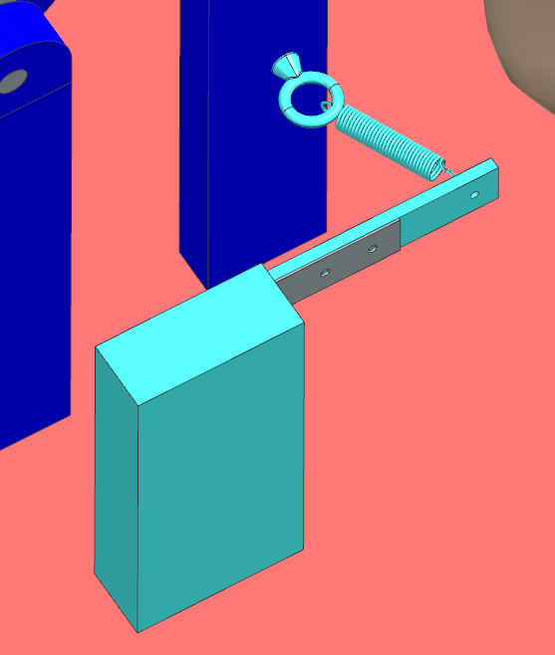.
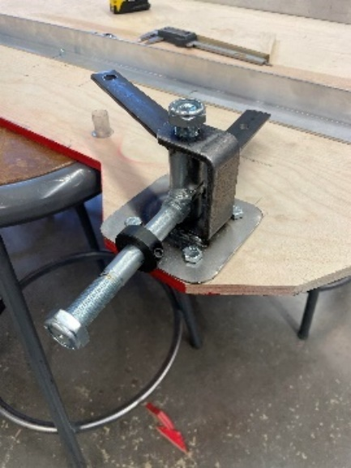
Picture 1

ANNEX B
MECHANICAL ANALYSIS

Frame:
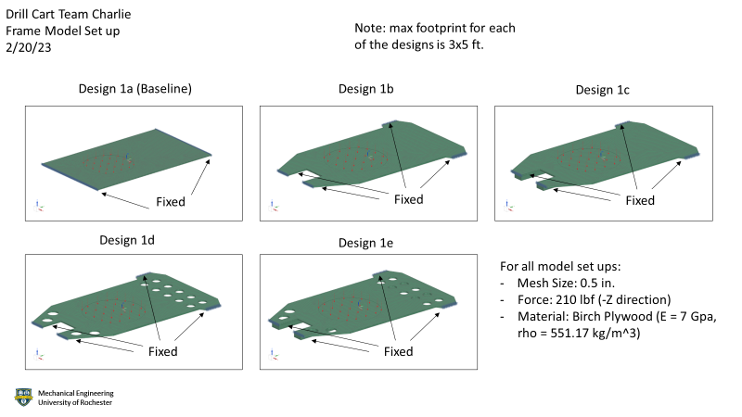
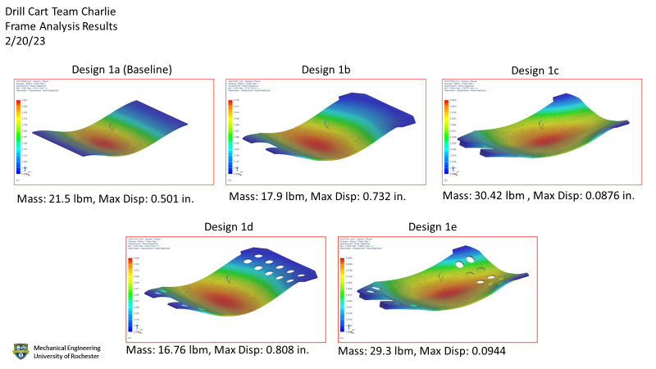

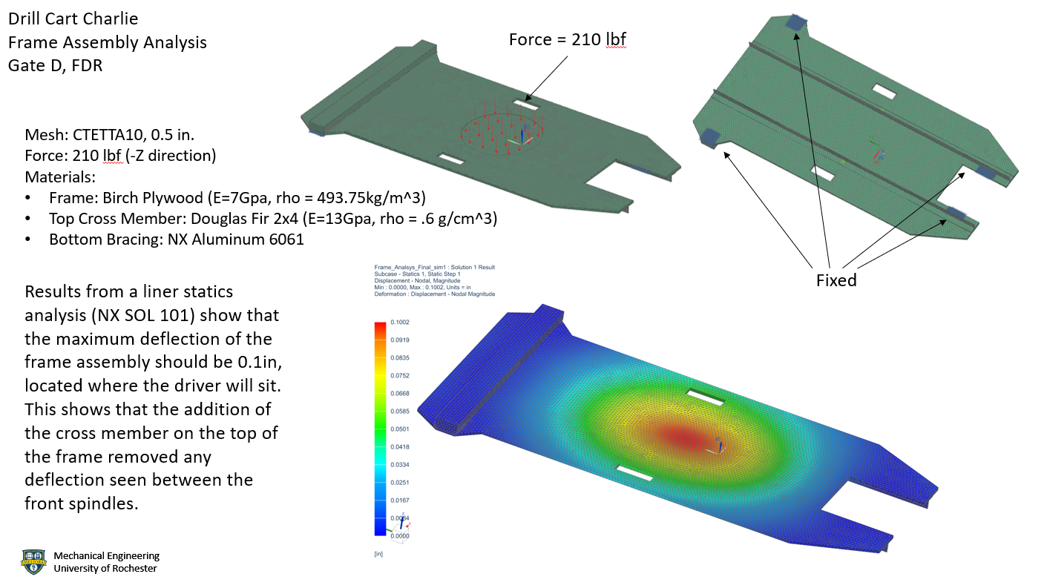

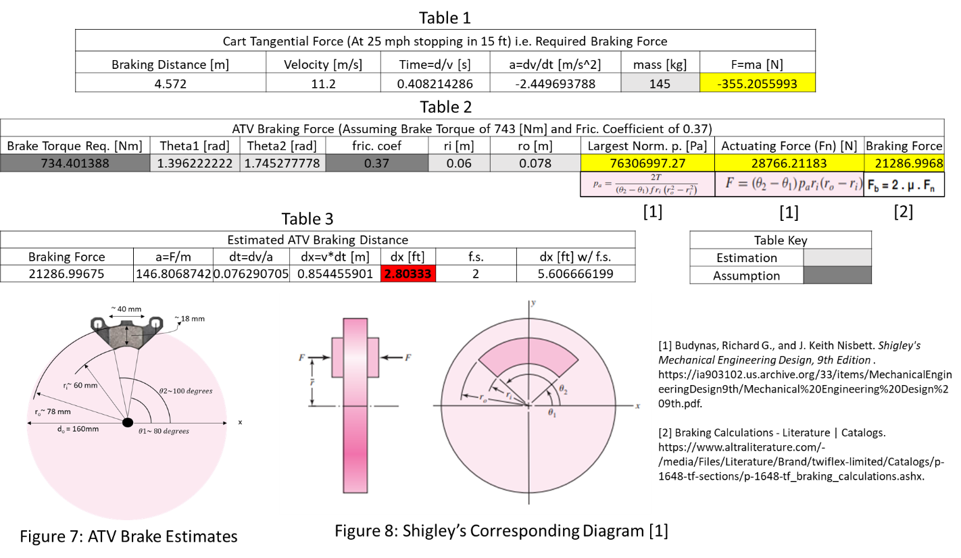
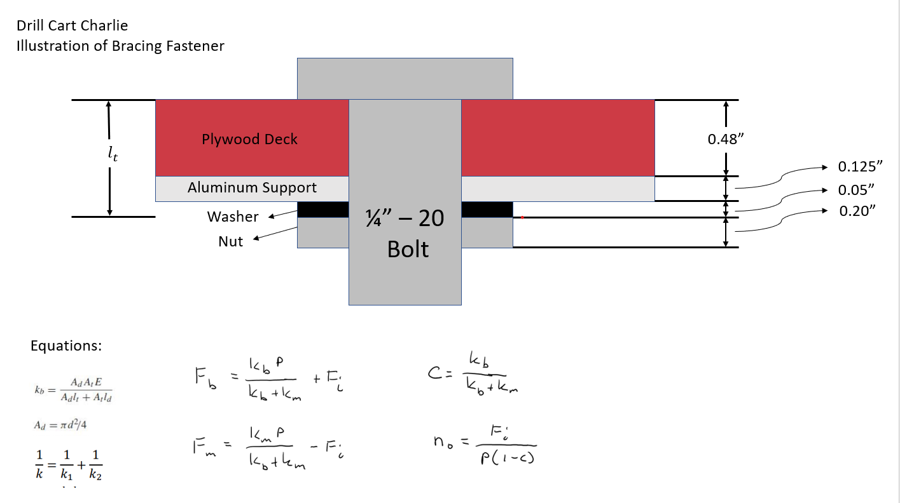

Braking:

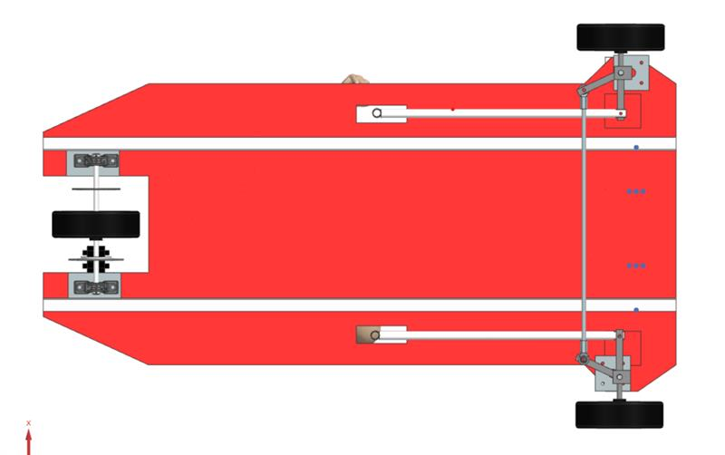
Steering:

Drivetrain:
Drivetrain Assembled on Cart

